



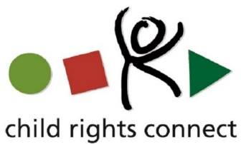

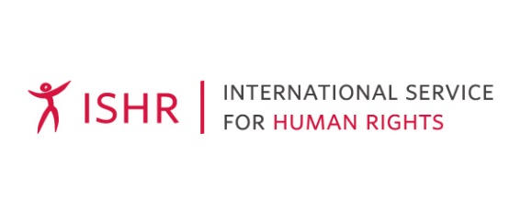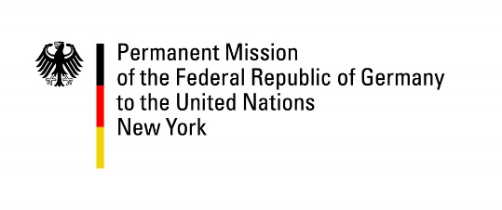

***

**CONCEPT NOTE**

**Side Event**

*A case for the ratification of the Optional Protocol to the Convention on the Rights of the Child on a Communications Procedure (OPIC)*

**13:15hrs- 14:30hrs, 8 November 2019**

**Venue: Room E, United Nations Headquarters**

**New York, United States of America**

The Third Optional Protocol to the Convention on the Rights of the Child (UNCRC) on a Communications Procedure (OPIC), which celebrates this year the 5th anniversary of its entry into force, sets out an individual and inter-states complaints procedure, and an inquiry procedure for child rights violations. It allows children from States parties to the Protocol to bring complaints about violations of their rights directly to the UN Committee on the Rights of the Child (Committee). Individual communications are subject to admissibility criteria under article 7 of the Option Protocol which includes the exhaustion of domestic remedies. The exhaustion of such remedies is not required for the submission of an inquiry request.

Since 14 April 2014 – the entry into force of the Optional Protocol – 46 States have ratified the OPIC and 18 have signed but not yet ratified it. The Committee has been receiving individual communications through the Petitions Section in the Office of the High Commissioner for Human Rights and has started to conduct inquiries into allegation of grave or systematic violations of human rights. By mid October 2019, the Committee had registered 100 individual communications and adopted 30 decisions on such communications, including 8 decisions on the merits, 14 decisions on the admissibility and 8 discontinuances; It had 70 pending cases and was starting the follow-up process for its first decisions. It had also discontinued an inquiry and concluded another one, the report concerning the latter was published in June 2018.

The OPIC is the most recent Optional Protocol establishing a communications procedure within the UN Treaty Body system. It builds on and expands the existing highest standards from other treaties and therefore it bears huge potential to strengthen the implementation of the UNCRC and the realisation of children’s rights on the ground. The OPIC is, first and foremost, a unique tool that States should use to strengthen their legal systems for the protection of child rights. Positive examples of the progress possible thanks to the implementation of the OPIC already exists, some of which have been gathered in the Report on Key findings of Roundtable Discussion: “[Towards a better implementation of the UN CRC through its 3rd Optional Protocol on a Communications Procedure](http://opic.childrightsconnect.org/wp-content/uploads/2019/08/REPORT_-OPIC_Roundtable_Discussion.pdf).”

However, the potential of the Protocol to trigger broader change in national legislation and systems for remedies can only be achieved if more States ratify it to make this mechanism accessible to children on a broader global scale and if States implement the Committee’s Views and recommendations.

While the UNCRC is the most widely ratified treaty in the world (196 States parties), only 20% of those who have ratified the UNCRC, have ratified the OPIC so far. In contrast, more than 80% of the States having ratified the UNCRC are parties to the Optional Protocol to the Convention on the involvement of children in armed conflict (OPAC), and almost 90% of the States parties to the UNCRC have ratified the Optional Protocol to the Convention on the sale of children, child prostitution and child pornography (OPSC).Why is the OPIC less ratified than the UNCRC and the first two Optional protocols to the Convention on the Rights of the Child?

***Why exactly is the ratification of the OPIC relevant for ensuring children’s rights?***

In the context of the 30th Anniversary of the UNCRC, the Committee has requested States parties to [provide information to the Committee on their commitments](https://www.ohchr.org/EN/HRBodies/CRC/Pages/CRC30.aspx) with respect to children’s rights, as well as national initiatives, in celebration of the 30th anniversary of the Convention. The ratification of the OPIC provides legitimacy to the pledges that States parties are making in the context of the UNCRC 30th Anniversary. Indeed, unless accountability for child rights violations is ensured, the rights of children lose their meaning. Further, the recognition that children have the right to appeal to an international mechanism specific to them, if violations cannot be addressed effectively at national level, is also the ultimate example of putting children’s right to be heard and participate into practice.

**Purpose of the event**

On the occasion of the 5th anniversary of the entry into force of OPIC and the 30th anniversary of the UNCRC, Child Rights Connect[1], the Special Representative of the UN Secretary-General on Violence against Children and the Committee, wish to **reinforce States’ commitments to OPIC** and **increase general understanding of the added value** that OPIC brings to the realisation of children’s rights. The event will highlight that children’s rights can only be realised if all of the child rights specific treaties (UNCRC and its three Optional Protocols) are ratified and implemented.

**Agenda  
Moderated by** Olivia Solari Yrigoyen, Legal Officer at Child Rights Connect

|  |  |
| --- | --- |
| **Opening remarks**  **Video message**  **Panellists:**  **Closing remarks**  **Questions from the floor** | * H.E Ambassador Michal Mlynár - Permanent Representative of the Slovak Republic to the United Nations * Save the Children Young Voices Mongolia * Alex Conte – Executive Director, Child Rights Connect * Najat Maalla M’jid - Special Representative of the Secretary-General on Violence Against Children * Benyam Dawit Mezmur – member of the UN Committee on the Rights of the Child * H.E. Ambassador Darja Bavdaž Kuret - Permanent Representative of the Republic of Slovenia to the United Nations * Q&A / open mic for audience to engage the room |

1. Child Rights Connect has played a leading role in the drafting, adoption and supporting the ratification of OPIC. It led and coordinated the NGOs international campaign for drafting and adoption of the optional protocol, and in 2012 founded the Ratify OP3 CRC – the International Coalition for the OP3 CRC on a Communications Procedure- to mobilise the world to advocate for the ratification of this new treaty. The work of the Ratify OP3 CRC Coalition has now been integrated into the core work of Child Rights Connect and the Coalition has been dissolved.